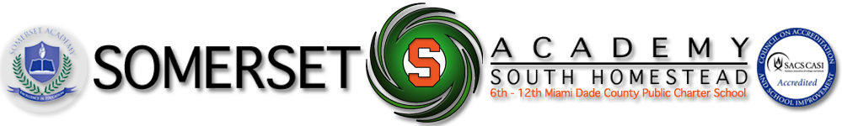Focus Calendar

*September 2021*

**Teacher:** __________Ms.Gonzalez_____________________ **Subject:**_______Civics______________________________

**Data Source Used to Determine Focus Areas:** ___ Study Island_________________________________________

|  |  |  |  |  |  |
| --- | --- | --- | --- | --- | --- |
| **Week of** | **Pacing Guide Benchmark(s)** | **Focus Benchmark** | **How will focus benchmark**  **be incorporated into lesson?** | **How will focus benchmark be assessed?** | **When will focus benchmark be assessed?** |
| September 6 – September 10, 2021 | **SS.7.C.2.1: Define the term "citizen," and identify legal means of becoming a United States citizen.**  **SS.7.C.2.2: Evaluate the obligations citizens have to obey laws, pay taxes, defend the nation, and serve on juries.** | • Students will define citizenship as stated in the Fourteenth Amendment.  • Students will describe the process of becoming a naturalized citizen.  • Students will evaluate the impact of the naturalization process on society government, or the political process. | Students will evaluate the roles, rights, and responsibilities of U.S. citizens, and determine methods of active participation in society, government, and the political system. | Practice EOC Questions | End of Week |
| September 13- September 17, 2021 | **SS.7.C.1.1: Recognize how Enlightenment ideas including Montesquieu's view of separation of power and John Locke's theories related to natural law and how Locke's social contract influenced the Founding Fathers.**  **SS.7.C.1.2: Trace the impact that the Magna Carta, English Bill of Rights, Mayflower Compact, and Thomas Paine's "Common Sense" had on colonists' views of government.** | Students will identify and describe the Enlightenment ideas of separation of powers, natural law, and social contract.  • Students will examine how Enlightenment ideas influenced the Founders’ beliefs about individual liberties and government.  • Students will evaluate the influence of Montesquieu’s and Locke’s ideas on the Founding Fathers.  Students will identify the important ideas contained in the Magna Carta, English Bill of Rights, Mayflower Compact, and Common Sense.  • Students will evaluate the impact that the Magna Carta, English Bill of Rights, Mayflower Compact, and Common Sense had on the purposes of government. | Students will demonstrate an understanding of the origins and purposes of government, law, and the American political system. | Practice EOC Questions | End of Week |
| September 20- September 24, 2021 | **SS.7.C.1.3: Describe how English policies and responses to colonial concerns led to the writing of the Declaration of Independence.**  **SS.7.C.1.4: Analyze the ideas (natural rights, role of the government) and complaints set forth in the Declaration of Independence.** | Students will trace the causal relationships between English/British policies, English responses to colonial grievances, and the writing of the Declaration of Independence.  • Students will recognize the underlying themes of English colonial policies concerning  taxation, representation, and individual rights that formed the basis of the American colonists’ desire for independence.  • Students will explain the concept of natural rights as expressed in the Declaration of Independence.  • Students will identify the natural rights specifically expressed in the Declaration of Independence (life, liberty, and the pursuit of happiness).  • Students will analyze the relationship between natural rights and the role of government: 1. People are endowed by their Creator with certain unalienable rights;2.Governments are instituted among men to secure these rights; 3. Governments derive their just powers from the consent of governed; and 4. Whenever any form of government becomes destructive of these ends, it is the right of the people to alter or abolish it, and to institute new government.  • Students will recognize the connection between specific grievances in the Declaration of Independence and natural rights’ violations.  • Students will recognize colonial complaints as identified in the Declaration of Independence: Imposing taxes without the consent of the people, suspending trial by jury, limiting judicial powers, quartering soldiers, and dissolving legislatures | Students will demonstrate an understanding of the origins and purposes of government, law, and the American political system. | Practice EOC Questions | End of Week |
| September 27 - October 1, 2021 | **SS.7.C.1.5:** *Identify how the weaknesses of the Articles of Confederation led to the writing of the Constitution.* | Students will identify the weaknesses of the government under the Articles of Confederation (i.e., Congress had no power to tax, to regulate trade, or to enforce its laws; the national government lacked a national court system [judicial branch] and central leadership [executive branch]; and changes to the Articles required unanimous consent of the 13 states). | Students will demonstrate an understanding of the origins and purposes of government, law, and the American political system. | Practice EOC Questions | End of Week |